Chapter 07
Capital Asset Pricing and Arbitrage Pricing Theory

Multiple Choice Questions
1. | An adjusted beta will be ______ than the unadjusted beta.  A. lower  B. higher  C. closer to 1  D. closer to 0

2. | Fama and French claim that after controlling for firm size and the ratio of the firm's book value to market value, beta is:  I. Highly significant in predicting future stock returns  II. Relatively useless in predicting future stock returns  III. A good predictor of the firm's specific risk  A. I only  B. II only  C. I and III only  D. I, II, and III

3. | Which of the following are assumptions of the simple CAPM model?  I. Individual trades of investors do not affect a stock's price.  II. All investors plan for one identical holding period.  III. All investors analyze securities in the same way and share the same economic view of the world.  IV. All investors have the same level of risk aversion.  A. I, II, and IV only  B. I, II, and III only  C. II, III, and IV only  D. I, II, III, and IV

4. | When all investors analyze securities in the same way and share the same economic view of the world, we say they have ____________________.  A. heterogeneous expectations  B. equal risk aversion  C. asymmetric information  D. homogeneous expectations

5. | In a simple CAPM world which of the following statements is (are) correct?  I. All investors will choose to hold the market portfolio, which includes all risky assets in the world.  II. Investors' complete portfolio will vary depending on their risk aversion.  III. The return per unit of risk will be identical for all individual assets.  IV. The market portfolio will be on the efficient frontier, and it will be the optimal risky portfolio.  A. I, II, and III only  B. II, III, and IV only  C. I, III, and IV only  D. I, II, III, and IV

6. | Consider the CAPM. The risk-free rate is 6%, and the expected return on the market is 18%. What is the expected return on a stock with a beta of 1.3?  A. 6%  B. 15.6%  C. 18%  D. 21.6%

7. | Consider the CAPM. The risk-free rate is 5%, and the expected return on the market is 15%. What is the beta on a stock with an expected return of 17%?  A. .5  B. .7  C. 1  D. 1.2

8. | Consider the CAPM. The expected return on the market is 18%. The expected return on a stock with a beta of 1.2 is 20%. What is the risk-free rate?  A. 2%  B. 6%  C. 8%  D. 12%

9. | The arbitrage pricing theory was developed by _________.  A. Henry Markowitz  B. Stephen Ross  C. William Sharpe  D. Eugene Fama

10. | In the context of the capital asset pricing model, the systematic measure of risk is captured by _________.  A. unique risk  B. beta  C. the standard deviation of returns  D. the variance of returns

11. | Empirical results estimated from historical data indicate that betas _________.  A. are always close to zero  B. are constant over time  C. of all securities are always between zero and 1  D. seem to regress toward 1 over time

12. | If enough investors decide to purchase stocks, they are likely to drive up stock prices, thereby causing _____________ and ___________.  A. expected returns to fall; risk premiums to fall  B. expected returns to rise; risk premiums to fall  C. expected returns to rise; risk premiums to rise  D. expected returns to fall; risk premiums to rise

13. | The market portfolio has a beta of _________.  A. -1  B. 0  C. .5  D. 1

14. | In a well-diversified portfolio, __________ risk is negligible.  A. nondiversifiable  B. market  C. systematic  D. unsystematic

15. | The capital asset pricing model was developed by _________.  A. Kenneth French  B. Stephen Ross  C. William Sharpe  D. Eugene Fama

16. | If all investors become more risk averse, the SML will _______________ and stock prices will _______________.  A. shift upward; rise  B. shift downward; fall  C. have the same intercept with a steeper slope; fall  D. have the same intercept with a flatter slope; rise

17. | According to the capital asset pricing model, a security with a _________.  A. negative alpha is considered a good buy  B. positive alpha is considered overpriced  C. positive alpha is considered underpriced  D. zero alpha is considered a good buy

18. | Arbitrage is based on the idea that _________.  A. assets with identical risks must have the same expected rate of return  B. securities with similar risk should sell at different prices  C. the expected returns from equally risky assets are different  D. markets are perfectly efficient

19. | Investors require a risk premium as compensation for bearing ______________.  A. unsystematic risk  B. alpha risk  C. residual risk  D. systematic risk

20. | According to the capital asset pricing model, a fairly priced security will plot _________.  A. above the security market line  B. along the security market line  C. below the security market line  D. at no relation to the security market line

21. | According to the capital asset pricing model, fairly priced securities have _________.  A. negative betas  B. positive alphas  C. positive betas  D. zero alphas

22. | You have a $50,000 portfolio consisting of Intel, GE, and Con Edison. You put $20,000 in Intel, $12,000 in GE, and the rest in Con Edison. Intel, GE, and Con Edison have betas of 1.3, 1, and .8, respectively. What is your portfolio beta?  A. 1.048  B. 1.033  C. 1  D. 1.037

23. | The graph of the relationship between expected return and beta in the CAPM context is called the _________.  A. CML  B. CAL  C. SML  D. SCL

24. | Research has revealed that regardless of what the current estimate of a firm's beta is, beta will tend to move closer to ______ over time.  A. 1  B. 0  C. -1  D. .5

25. | The beta of a security is equal to _________.  A. the covariance between the security and market returns divided by the variance of the market's returns  B. the covariance between the security and market returns divided by the standard deviation of the market's returns  C. the variance of the security's returns divided by the covariance between the security and market returns  D. the variance of the security's returns divided by the variance of the market's returns

26. | According to the capital asset pricing model, in equilibrium _________.  A. all securities' returns must lie below the capital market line  B. all securities' returns must lie on the security market line  C. the slope of the security market line must be less than the market risk premium  D. any security with a beta of 1 must have an excess return of zero

27. | According to the CAPM, which of the following is not a true statement regarding the market portfolio.  A. All securities in the market portfolio are held in proportion to their market values.  B. It includes all risky assets in the world, including human capital.  C. It is always the minimum-variance portfolio on the efficient frontier.  D. It lies on the efficient frontier.

28. | In a world where the CAPM holds, which one of the following is not a true statement regarding the capital market line?  A. The capital market line always has a positive slope.  B. The capital market line is also called the security market line.  C. The capital market line is the best-attainable capital allocation line.  D. The capital market line is the line from the risk-free rate through the market portfolio.

29. | Consider the single factor APT. Portfolio A has a beta of 1.3 and an expected return of 21%. Portfolio B has a beta of .7 and an expected return of 17%. The risk-free rate of return is 8%. If you wanted to take advantage of an arbitrage opportunity, you should take a short position in portfolio __________ and a long position in portfolio _________.  A. A; A  B. A; B  C. B; A  D. B; B

30. | Consider the single factor APT. Portfolio A has a beta of .2 and an expected return of 13%. Portfolio B has a beta of .4 and an expected return of 15%. The risk-free rate of return is 10%. If you wanted to take advantage of an arbitrage opportunity, you should take a short position in portfolio __________ and a long position in portfolio _________.  A. A; A  B. A; B  C. B; A  D. B; B

31. | Consider the multifactor APT with two factors. Portfolio A has a beta of .5 on factor 1 and a beta of 1.25 on factor 2. The risk premiums on the factor 1 and 2 portfolios are 1% and 7%, respectively. The risk-free rate of return is 7%. The expected return on portfolio A is __________ if no arbitrage opportunities exist.  A. 13.5%  B. 15%  C. 16.25%  D. 23%

32. | Consider the one-factor APT. The variance of the return on the factor portfolio is .08. The beta of a well-diversified portfolio on the factor is 1.2. The variance of the return on the well-diversified portfolio is approximately _________.  A. .1152  B. .1270  C. .1521  D. .1342

33. | Security X has an expected rate of return of 13% and a beta of 1.15. The risk-free rate is 5%, and the market expected rate of return is 15%. According to the capital asset pricing model, security X is _________.  A. fairly priced  B. overpriced  C. underpriced  D. none of these answers

34. | The possibility of arbitrage arises when ____________.  A. there is no consensus among investors regarding the future direction of the market, and thus trades are made arbitrarily  B. mispricing among securities creates opportunities for riskless profits  C. two identically risky securities carry the same expected returns  D. investors do not diversify

35. | Building a zero-investment portfolio will always involve _____________.  A. an unknown mixture of short and long positions  B. only short positions  C. only long positions  D. equal investments in a short and a long position

36. | An important characteristic of market equilibrium is _______________.  A. the presence of many opportunities for creating zero-investment portfolios  B. all investors exhibit the same degree of risk aversion  C. the absence of arbitrage opportunities  D. the lack of liquidity in the market

37. | Consider the capital asset pricing model. The market degree of risk aversion, A, is 3. The variance of return on the market portfolio is .0225. If the risk-free rate of return is 4%, the expected return on the market portfolio is _________.  A. 6.75%  B. 9%  C. 10.75%  D. 12%

38. | You invest $600 in security A with a beta of 1.5 and $400 in security B with a beta of .90. The beta of this portfolio is _________.  A. 1.14  B. 1.2  C. 1.26  D. 1.5

39. | In a single-factor market model the beta of a stock ________.  A. measures the stock's contribution to the standard deviation of the market portfolio  B. measures the stock's unsystematic risk  C. changes with the variance of the residuals  D. measures the stock's contribution to the standard deviation of the stock

40. | Security A has an expected rate of return of 12% and a beta of 1.1. The market expected rate of return is 8%, and the risk-free rate is 5%. The alpha of the stock is _________.  A. -1.7%  B. 3.7%  C. 5.5%  D. 8.7%

41. | The variance of the return on the market portfolio is .04 and the expected return on the market portfolio is 20%. If the risk-free rate of return is 10%, the market degree of risk aversion, A, is _________.  A. .5  B. 2.5  C. 3.5  D. 5

42. | The risk-free rate is 4%. The expected market rate of return is 11%. If you expect stock X with a beta of .8 to offer a rate of return of 12%, then you should _________.  A. buy stock X because it is overpriced  B. buy stock X because it is underpriced  C. sell short stock X because it is overpriced  D. sell short stock X because it is underpriced

43. | Consider the one-factor APT. The standard deviation of return on a well-diversified portfolio is 20%. The standard deviation on the factor portfolio is 12%. The beta of the well-diversified portfolio is approximately _________.  A. .60  B. 1  C. 1.67  D. 3.20

44. | The risk-free rate and the expected market rate of return are 6% and 16%, respectively. According to the capital asset pricing model, the expected rate of return on security X with a beta of 1.2 is equal to _________.  A. 12%  B. 17%  C. 18%  D. 23%

45. | Consider two stocks, A and B. Stock A has an expected return of 10% and a beta of 1.2. Stock B has an expected return of 14% and a beta of 1.8. The expected market rate of return is 9% and the risk-free rate is 5%. Security __________ would be considered the better buy because _________.  A. A; it offers an expected excess return of .2%  B. A; it offers an expected excess return of 2.2%  C. B; it offers an expected excess return of 1.8%  D. B; it offers an expected return of 2.4%

46. | According to the CAPM, the risk premium an investor expects to receive on any stock or portfolio is _______________.  A. directly related to the risk aversion of the particular investor  B. inversely related to the risk aversion of the particular investor  C. directly related to the beta of the stock  D. inversely related to the alpha of the stock

47. | In his famous critique of the CAPM, Roll argued that the CAPM ______________.  A. is not testable because the true market portfolio can never be observed  B. is of limited use because systematic risk can never be entirely eliminated  C. should be replaced by the APT  D. should be replaced by the Fama-French three-factor model

48. | Which of the following variables do Fama and French claim do a better job explaining stock returns than beta?  I. Book-to-market ratio  II. Unexpected change in industrial production  III. Firm size  A. I only  B. I and II only  C. I and III only  D. I, II, and III

49. | In a study conducted by Jagannathan and Wang, it was found that the performance of beta in explaining security returns could be considerably enhanced by:  I. Including the unsystematic risk of a stock  II. Including human capital in the market portfolio  III. Allowing for changes in beta over time  A. I and II only  B. II and III only  C. I and III only  D. I, II, and III

50. | The SML is valid for _______________, and the CML is valid for ______________.  A. only individual assets; well-diversified portfolios only  B. only well-diversified portfolios; only individual assets  C. both well-diversified portfolios and individual assets; both well-diversified portfolios and individual assets  D. both well-diversified portfolios and individual assets; well-diversified portfolios only

51. | Liquidity is a risk factor that __________.  A. has yet to be accurately measured and incorporated into portfolio management  B. is unaffected by trading mechanisms on various stock exchanges  C. has no effect on the market value of an asset  D. affects bond prices but not stock prices

52. | Beta is a measure of ______________.  A. total risk  B. relative systematic risk  C. relative nonsystematic risk  D. relative business risk

53. | According to capital asset pricing theory, the key determinant of portfolio returns is _________.  A. the degree of diversification  B. the systematic risk of the portfolio  C. the firm-specific risk of the portfolio  D. economic factors

54. | The expected return of the risky-asset portfolio with minimum variance is _________.  A. the market rate of return  B. zero  C. the risk-free rate  D. The answer cannot be determined from the information given.

55. | According to the CAPM, investors are compensated for all but which of the following?  A. Expected inflation  B. Systematic risk  C. Time value of money  D. Residual risk

56. | The most significant conceptual difference between the arbitrage pricing theory (APT) and the capital asset pricing model (CAPM) is that the CAPM _____________.  A. places less emphasis on market risk  B. recognizes multiple unsystematic risk factors  C. recognizes only one systematic risk factor  D. recognizes multiple systematic risk factors

57. | Arbitrage is __________________________.  A. an example of the law of one price  B. the creation of riskless profits made possible by relative mispricing among securities  C. a common opportunity in modern markets  D. an example of a risky trading strategy based on market forecasting

58. | A stock's alpha measures the stock's ____________________.  A. expected return  B. abnormal return  C. excess return  D. residual return

59. | The measure of unsystematic risk can be found from an index model as _________.  A. residual standard deviation  B. R-square  C. degrees of freedom  D. sum of squares of the regression

60. | Standard deviation of portfolio returns is a measure of ___________.  A. total risk  B. relative systematic risk  C. relative nonsystematic risk  D. relative business risk

61. | One of the main problems with the arbitrage pricing theory is __________.  A. its use of several factors instead of a single market index to explain the risk-return relationship  B. the introduction of nonsystematic risk as a key factor in the risk-return relationship  C. that the APT requires an even larger number of unrealistic assumptions than does the CAPM  D. the model fails to identify the key macroeconomic variables in the risk-return relationship

62. | You run a regression of a stock's returns versus a market index and find the following:  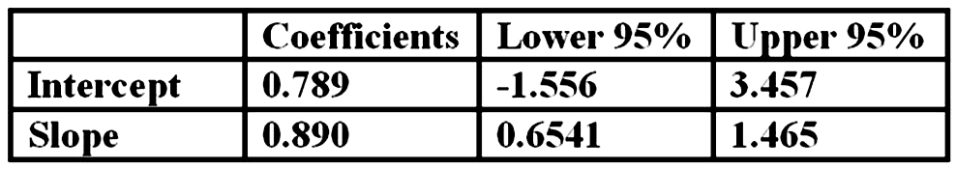  Based on the data, you know that the stock _____.  A. earned a positive alpha that is statistically significantly different from zero  B. has a beta precisely equal to .890  C. has a beta that is likely to be anything between .6541 and 1.465 inclusive  D. has no systematic risk

63. | The expected return on the market portfolio is 15%. The risk-free rate is 8%. The expected return on SDA Corp. common stock is 16%. The beta of SDA Corp. common stock is 1.25. Within the context of the capital asset pricing model, _________.  A. SDA Corp. stock is underpriced  B. SDA Corp. stock is fairly priced  C. SDA Corp. stock's alpha is -.75%  D. SDA Corp. stock alpha is .75%

64. | Assume that both X and Y are well-diversified portfolios and the risk-free rate is 8%. Portfolio X has an expected return of 14% and a beta of 1. Portfolio Y has an expected return of 9.5% and a beta of .25. In this situation, you would conclude that portfolios X and Y _________.  A. are in equilibrium  B. offer an arbitrage opportunity  C. are both underpriced  D. are both fairly priced

65. | 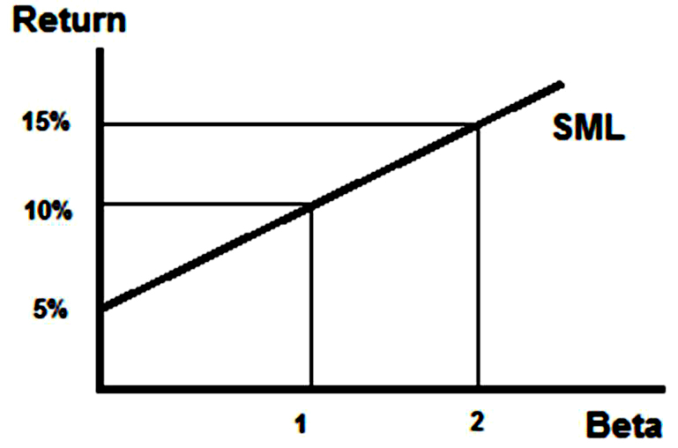  What is the expected return on the market?  A. 0%  B. 5%  C. 10%  D. 15%

66. | 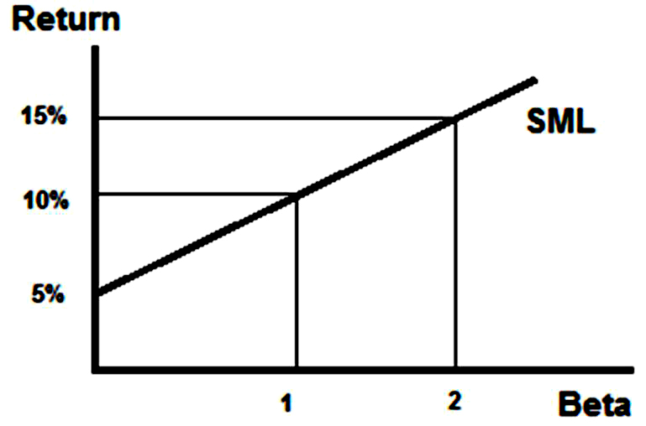  What is the beta for a portfolio with an expected return of 12.5%?  A. 0  B. 1  C. 1.5  D. 2

67. | What is the expected return for a portfolio with a beta of .5?  A. 5%  B. 7.5%  C. 12.5%  D. 15%

68. | What is the alpha of a portfolio with a beta of 2 and actual return of 15%?  A. 0%  B. 13%  C. 15%  D. 17%

69. | If the simple CAPM is valid and all portfolios are priced correctly, which of the situations below is possible? Consider each situation independently, and assume the risk-free rate is 5%.  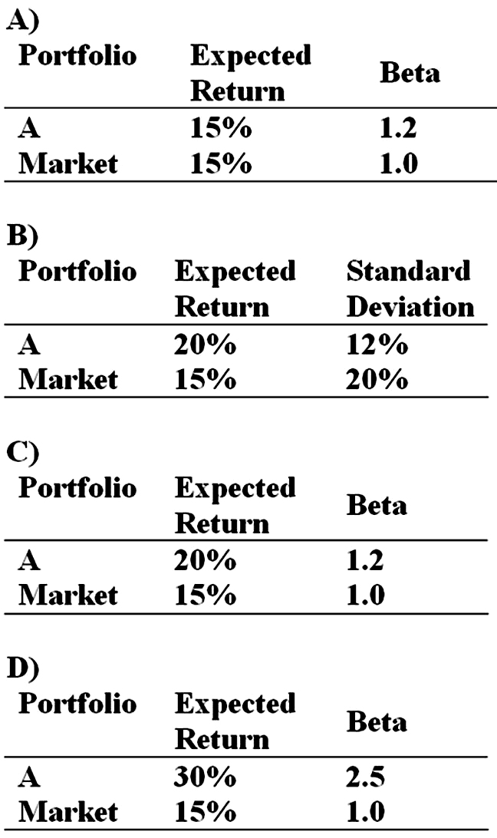  A. Option A  B. Option B  C. Option C  D. Option D

70. | Two investment advisers are comparing performance. Adviser A averaged a 20% return with a portfolio beta of 1.5, and adviser B averaged a 15% return with a portfolio beta of 1.2. If the T-bill rate was 5% and the market return during the period was 13%, which adviser was the better stock picker?  A. Advisor A was better because he generated a larger alpha.  B. Advisor B was better because she generated a larger alpha.  C. Advisor A was better because he generated a higher return.  D. Advisor B was better because she achieved a good return with a lower beta.

71. | The expected return on the market is the risk-free rate plus the _____________.  A. diversified returns  B. equilibrium risk premium  C. historical market return  D. unsystematic return

72. | You consider buying a share of stock at a price of $25. The stock is expected to pay a dividend of $1.50 next year, and your advisory service tells you that you can expect to sell the stock in 1 year for $28. The stock's beta is 1.1, r_{f} is 6%, and E[r_{m}] = 16%. What is the stock's abnormal return?  A. 1%  B. 2%  C. -1%  D. -2%

73. | If the beta of the market index is 1 and the standard deviation of the market index increases from 12% to 18%, what is the new beta of the market index?  A. .8  B. 1  C. 1.2  D. 1.5

74. | According to the CAPM, what is the market risk premium given an expected return on a security of 13.6%, a stock beta of 1.2, and a risk-free interest rate of 4%?  A. 4%  B. 4.8%  C. 6.6%  D. 8%

75. | According to the CAPM, what is the expected market return given an expected return on a security of 15.8%, a stock beta of 1.2, and a risk-free interest rate of 5%?  A. 5%  B. 9%  C. 13%  D. 14%

76. | What is the expected return on a stock with a beta of .8, given a risk-free rate of 3.5% and an expected market return of 15.5%?  A. 3.8%  B. 13.1%  C. 15.6%  D. 19.1%

77. | Research has identified two systematic factors that affect U.S. stock returns. The factors are growth in industrial production and changes in long-term interest rates. Industrial production growth is expected to be 3%, and long-term interest rates are expected to increase by 1%. You are analyzing a stock that has a beta of 1.2 on the industrial production factor and .5 on the interest rate factor. It currently has an expected return of 12%. However, if industrial production actually grows 5% and interest rates drop 2%, what is your best guess of the stock's return?  A. 15.9%  B. 12.9%  C. 13.2%  D. 12%

78. | A stock has a beta of 1.3. The systematic risk of this stock is ____________ the stock market as a whole.  A. higher than  B. lower than  C. equal to  D. indeterminable compared to

79. | There are two independent economic factors, M1 and M2. The risk-free rate is 5%, and all stocks have independent firm-specific components with a standard deviation of 25%. Portfolios A and B are well diversified. Given the data below, which equation provides the correct pricing model?  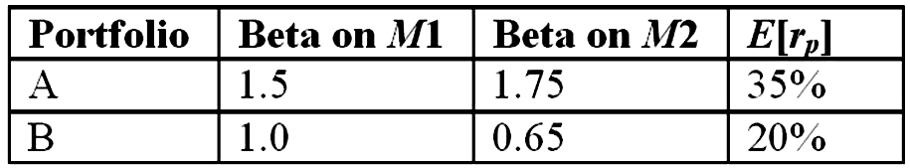  A. E(r_{P}) = 5 + 1.12β_{P1} + 11.86β_{P2}  B. E(r_{P}) = 5 + 4.96β_{P1} + 13.26β_{P2}  C. E(r_{P}) = 5 + 3.23β_{P1} + 8.46β_{P2}  D. E(r_{P}) = 5 + 8.71β_{P1} + 9.68β_{P2}

80. | Using the index model, the alpha of a stock is 3%, the beta is 1.1, and the market return is 10%. What is the residual given an actual return of 15%?  A. .0%  B. 1%  C. 2%  D. 3%

81. | The risk premium for exposure to aluminum commodity prices is 4%, and the firm has a beta relative to aluminum commodity prices of .6. The risk premium for exposure to GDP changes is 6%, and the firm has a beta relative to GDP of 1.2. If the risk-free rate is 4%, what is the expected return on this stock?  A. 10%  B. 11.5%  C. 13.6%  D. 14%

82. | The two-factor model on a stock provides a risk premium for exposure to market risk of 9%, a risk premium for exposure to interest rate risk of (-1.3%), and a risk-free rate of 3.5%. The beta for exposure to market risk is 1, and the beta for exposure to interest rate risk is also 1. What is the expected return on the stock?  A. 8.7%  B. 11.2%  C. 13.8%  D. 15.2%

83. | The risk premium for exposure to exchange rates is 5%, and the firm has a beta relative to exchange rates of .4. The risk premium for exposure to the consumer price index is -6%, and the firm has a beta relative to the CPI of .8. If the risk-free rate is 3%, what is the expected return on this stock?  A. .2%  B. 1.5%  C. 3.6%  D. 4%

84. | The two-factor model on a stock provides a risk premium for exposure to market risk of 12%, a risk premium for exposure to silver commodity prices of 3.5%, and a risk-free rate of 4%. The beta for exposure to market risk is 1, and the beta for exposure to commodity prices is also 1. What is the expected return on the stock?  A. 11.6%  B. 13%  C. 15.3%  D. 19.5%

85. | The measure of risk used in the capital asset pricing model is ___________.  A. specific risk  B. the standard deviation of returns  C. reinvestment risk  D. beta

Chapter 07 Capital Asset Pricing and Arbitrage Pricing Theory Answer Key

Multiple Choice Questions
1. | An adjusted beta will be ______ than the unadjusted beta.  A. lower  B. higher  C. closer to 1  D. closer to 0

AACSB: Analytic
Blooms: Remember
Difficulty: 2 Medium
Learning Objective: 07-01 Use the implications of capital market theory to estimate security risk premiums.
Topic: The CAPM and Index Models

2. | Fama and French claim that after controlling for firm size and the ratio of the firm's book value to market value, beta is:  I. Highly significant in predicting future stock returns  II. Relatively useless in predicting future stock returns  III. A good predictor of the firm's specific risk  A. I only  B. II only  C. I and III only  D. I, II, and III

AACSB: Analytic
Blooms: Remember
Difficulty: 2 Medium
Learning Objective: 07-03 Specify and use a multifactor security market line.
Topic: Multifactor Models and the CAPM

3. | Which of the following are assumptions of the simple CAPM model?  I. Individual trades of investors do not affect a stock's price.  II. All investors plan for one identical holding period.  III. All investors analyze securities in the same way and share the same economic view of the world.  IV. All investors have the same level of risk aversion.  A. I, II, and IV only  B. I, II, and III only  C. II, III, and IV only  D. I, II, III, and IV

AACSB: Analytic
Blooms: Remember
Difficulty: 2 Medium
Learning Objective: 07-01 Use the implications of capital market theory to estimate security risk premiums.
Topic: The Capital Asset Pricing Model

4. | When all investors analyze securities in the same way and share the same economic view of the world, we say they have ____________________.  A. heterogeneous expectations  B. equal risk aversion  C. asymmetric information  D. homogeneous expectations

AACSB: Analytic
Blooms: Remember
Difficulty: 1 Easy
Learning Objective: 07-01 Use the implications of capital market theory to estimate security risk premiums.
Topic: The Capital Asset Pricing Model

5. | In a simple CAPM world which of the following statements is (are) correct?  I. All investors will choose to hold the market portfolio, which includes all risky assets in the world.  II. Investors' complete portfolio will vary depending on their risk aversion.  III. The return per unit of risk will be identical for all individual assets.  IV. The market portfolio will be on the efficient frontier, and it will be the optimal risky portfolio.  A. I, II, and III only  B. II, III, and IV only  C. I, III, and IV only  D. I, II, III, and IV

AACSB: Analytic
Blooms: Remember
Difficulty: 3 Hard
Learning Objective: 07-01 Use the implications of capital market theory to estimate security risk premiums.
Topic: The Capital Asset Pricing Model

6. | Consider the CAPM. The risk-free rate is 6%, and the expected return on the market is 18%. What is the expected return on a stock with a beta of 1.3?  A. 6%  B. 15.6%  C. 18%  D. 21.6%  E[r_{s}] = 6% + [18% - 6%](1.3) = 21.6%

AACSB: Analytic
Blooms: Apply
Difficulty: 2 Medium
Learning Objective: 07-01 Use the implications of capital market theory to estimate security risk premiums.
Topic: The Capital Asset Pricing Model

7. | Consider the CAPM. The risk-free rate is 5%, and the expected return on the market is 15%. What is the beta on a stock with an expected return of 17%?  A. .5  B. .7  C. 1  D. 1.2  17% = 5% + [15% - 5%]β_{s}; β_{s} = 1.2

AACSB: Analytic
Blooms: Apply
Difficulty: 2 Medium
Learning Objective: 07-01 Use the implications of capital market theory to estimate security risk premiums.
Topic: The Capital Asset Pricing Model

8. | Consider the CAPM. The expected return on the market is 18%. The expected return on a stock with a beta of 1.2 is 20%. What is the risk-free rate?  A. 2%  B. 6%  C. 8%  D. 12%  20% = r_{F} + (18 - r_{F})(1.2); r_{F} = 8%

AACSB: Analytic
Blooms: Apply
Difficulty: 2 Medium
Learning Objective: 07-01 Use the implications of capital market theory to estimate security risk premiums.
Topic: The Capital Asset Pricing Model

9. | The arbitrage pricing theory was developed by _________.  A. Henry Markowitz  B. Stephen Ross  C. William Sharpe  D. Eugene Fama

AACSB: Analytic
Blooms: Remember
Difficulty: 1 Easy
Learning Objective: 07-04 Take advantage of an arbitrage opportunity with a portfolio that includes mispriced securities.
Topic: Arbitrage Pricing Theory

10. | In the context of the capital asset pricing model, the systematic measure of risk is captured by _________.  A. unique risk  B. beta  C. the standard deviation of returns  D. the variance of returns

AACSB: Analytic
Blooms: Remember
Difficulty: 1 Easy
Learning Objective: 07-01 Use the implications of capital market theory to estimate security risk premiums.
Topic: The Capital Asset Pricing Model

11. | Empirical results estimated from historical data indicate that betas _________.  A. are always close to zero  B. are constant over time  C. of all securities are always between zero and 1  D. seem to regress toward 1 over time

AACSB: Analytic
Blooms: Remember
Difficulty: 1 Easy
Learning Objective: 07-01 Use the implications of capital market theory to estimate security risk premiums.
Topic: The CAPM and Index Models

12. | If enough investors decide to purchase stocks, they are likely to drive up stock prices, thereby causing _____________ and ___________.  A. expected returns to fall; risk premiums to fall  B. expected returns to rise; risk premiums to fall  C. expected returns to rise; risk premiums to rise  D. expected returns to fall; risk premiums to rise

AACSB: Reflective Thinking
Blooms: Understand
Difficulty: 2 Medium
Learning Objective: 07-02 Construct and use the security market line.
Topic: The Security Market Line (B-level head)

13. | The market portfolio has a beta of _________.  A. -1  B. 0  C. .5  D. 1

AACSB: Analytic
Blooms: Remember
Difficulty: 1 Easy
Learning Objective: 07-01 Use the implications of capital market theory to estimate security risk premiums.
Topic: The CAPM and Index Models

14. | In a well-diversified portfolio, __________ risk is negligible.  A. nondiversifiable  B. market  C. systematic  D. unsystematic

AACSB: Analytic
Blooms: Remember
Difficulty: 1 Easy
Learning Objective: 07-01 Use the implications of capital market theory to estimate security risk premiums.
Topic: The Capital Asset Pricing Model

15. | The capital asset pricing model was developed by _________.  A. Kenneth French  B. Stephen Ross  C. William Sharpe  D. Eugene Fama

AACSB: Analytic
Blooms: Remember
Difficulty: 1 Easy
Learning Objective: 07-01 Use the implications of capital market theory to estimate security risk premiums.
Topic: The Capital Asset Pricing Model

16. | If all investors become more risk averse, the SML will _______________ and stock prices will _______________.  A. shift upward; rise  B. shift downward; fall  C. have the same intercept with a steeper slope; fall  D. have the same intercept with a flatter slope; rise

AACSB: Reflective Thinking
Blooms: Understand
Difficulty: 2 Medium
Learning Objective: 07-02 Construct and use the security market line.
Topic: The Security Market Line

17. | According to the capital asset pricing model, a security with a _________.  A. negative alpha is considered a good buy  B. positive alpha is considered overpriced  C. positive alpha is considered underpriced  D. zero alpha is considered a good buy

AACSB: Analytic
Blooms: Remember
Difficulty: 1 Easy
Learning Objective: 07-02 Construct and use the security market line.
Topic: The Security Market Line (B-level head)

18. | Arbitrage is based on the idea that _________.  A. assets with identical risks must have the same expected rate of return  B. securities with similar risk should sell at different prices  C. the expected returns from equally risky assets are different  D. markets are perfectly efficient

AACSB: Analytic
Blooms: Remember
Difficulty: 1 Easy
Learning Objective: 07-04 Take advantage of an arbitrage opportunity with a portfolio that includes mispriced securities.
Topic: Arbitrage Pricing Theory

19. | Investors require a risk premium as compensation for bearing ______________.  A. unsystematic risk  B. alpha risk  C. residual risk  D. systematic risk

AACSB: Analytic
Blooms: Remember
Difficulty: 1 Easy
Learning Objective: 07-01 Use the implications of capital market theory to estimate security risk premiums.
Topic: The Capital Asset Pricing Model

20. | According to the capital asset pricing model, a fairly priced security will plot _________.  A. above the security market line  B. along the security market line  C. below the security market line  D. at no relation to the security market line

AACSB: Analytic
Blooms: Remember
Difficulty: 1 Easy
Learning Objective: 07-02 Construct and use the security market line.
Topic: The Security Market Line

21. | According to the capital asset pricing model, fairly priced securities have _________.  A. negative betas  B. positive alphas  C. positive betas  D. zero alphas

AACSB: Analytic
Blooms: Remember
Difficulty: 2 Medium
Learning Objective: 07-02 Construct and use the security market line.
Topic: The Security Market Line

22. | You have a $50,000 portfolio consisting of Intel, GE, and Con Edison. You put $20,000 in Intel, $12,000 in GE, and the rest in Con Edison. Intel, GE, and Con Edison have betas of 1.3, 1, and .8, respectively. What is your portfolio beta?  A. 1.048  B. 1.033  C. 1  D. 1.037  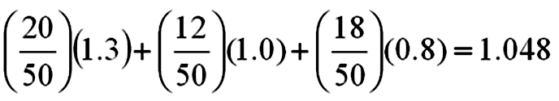

AACSB: Analytic
Blooms: Apply
Difficulty: 2 Medium
Learning Objective: 07-01 Use the implications of capital market theory to estimate security risk premiums.
Topic: The Capital Asset Pricing Model

23. | The graph of the relationship between expected return and beta in the CAPM context is called the _________.  A. CML  B. CAL  C. SML  D. SCL

AACSB: Analytic
Blooms: Remember
Difficulty: 1 Easy
Learning Objective: 07-02 Construct and use the security market line.
Topic: The Security Market Line (B-level head)

24. | Research has revealed that regardless of what the current estimate of a firm's beta is, beta will tend to move closer to ______ over time.  A. 1  B. 0  C. -1  D. .5

AACSB: Analytic
Blooms: Remember
Difficulty: 1 Easy
Learning Objective: 07-01 Use the implications of capital market theory to estimate security risk premiums.
Topic: The CAPM and Index Models

25. | The beta of a security is equal to _________.  A. the covariance between the security and market returns divided by the variance of the market's returns  B. the covariance between the security and market returns divided by the standard deviation of the market's returns  C. the variance of the security's returns divided by the covariance between the security and market returns  D. the variance of the security's returns divided by the variance of the market's returns

AACSB: Analytic
Blooms: Remember
Difficulty: 2 Medium
Learning Objective: 07-01 Use the implications of capital market theory to estimate security risk premiums.
Topic: The Capital Asset Pricing Model

26. | According to the capital asset pricing model, in equilibrium _________.  A. all securities' returns must lie below the capital market line  B. all securities' returns must lie on the security market line  C. the slope of the security market line must be less than the market risk premium  D. any security with a beta of 1 must have an excess return of zero

AACSB: Analytic
Blooms: Remember
Difficulty: 2 Medium
Learning Objective: 07-02 Construct and use the security market line.
Topic: The Security Market Line (B-level head)

27. | According to the CAPM, which of the following is not a true statement regarding the market portfolio.  A. All securities in the market portfolio are held in proportion to their market values.  B. It includes all risky assets in the world, including human capital.  C. It is always the minimum-variance portfolio on the efficient frontier.  D. It lies on the efficient frontier.

AACSB: Analytic
Blooms: Remember
Difficulty: 2 Medium
Learning Objective: 07-01 Use the implications of capital market theory to estimate security risk premiums.
Topic: The Capital Asset Pricing Model

28. | In a world where the CAPM holds, which one of the following is not a true statement regarding the capital market line?  A. The capital market line always has a positive slope.  B. The capital market line is also called the security market line.  C. The capital market line is the best-attainable capital allocation line.  D. The capital market line is the line from the risk-free rate through the market portfolio.

AACSB: Analytic
Blooms: Remember
Difficulty: 2 Medium
Learning Objective: 07-01 Use the implications of capital market theory to estimate security risk premiums.
Topic: The Capital Asset Pricing Model

29. | Consider the single factor APT. Portfolio A has a beta of 1.3 and an expected return of 21%. Portfolio B has a beta of .7 and an expected return of 17%. The risk-free rate of return is 8%. If you wanted to take advantage of an arbitrage opportunity, you should take a short position in portfolio __________ and a long position in portfolio _________.  A. A; A  B. A; B  C. B; A  D. B; B  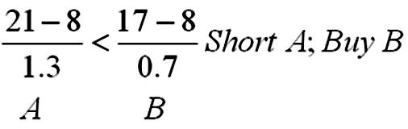

AACSB: Analytic
Blooms: Apply
Difficulty: 2 Medium
Learning Objective: 07-04 Take advantage of an arbitrage opportunity with a portfolio that includes mispriced securities.
Topic: Arbitrage Pricing Theory

30. | Consider the single factor APT. Portfolio A has a beta of .2 and an expected return of 13%. Portfolio B has a beta of .4 and an expected return of 15%. The risk-free rate of return is 10%. If you wanted to take advantage of an arbitrage opportunity, you should take a short position in portfolio __________ and a long position in portfolio _________.  A. A; A  B. A; B  C. B; A  D. B; B  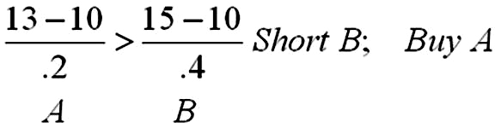

AACSB: Analytic
Blooms: Apply
Difficulty: 2 Medium
Learning Objective: 07-04 Take advantage of an arbitrage opportunity with a portfolio that includes mispriced securities.
Topic: Arbitrage Pricing Theory

31. | Consider the multifactor APT with two factors. Portfolio A has a beta of .5 on factor 1 and a beta of 1.25 on factor 2. The risk premiums on the factor 1 and 2 portfolios are 1% and 7%, respectively. The risk-free rate of return is 7%. The expected return on portfolio A is __________ if no arbitrage opportunities exist.  A. 13.5%  B. 15%  C. 16.25%  D. 23%  E(r_{A}) = 7 + 0.5(1) + 1.25(7) = 16.25%

AACSB: Analytic
Blooms: Apply
Difficulty: 2 Medium
Learning Objective: 07-05 Use arbitrage pricing theory with more than one factor to identify mispriced securities.
Topic: Multifactor Generalization of the APT and CAPM

32. | Consider the one-factor APT. The variance of the return on the factor portfolio is .08. The beta of a well-diversified portfolio on the factor is 1.2. The variance of the return on the well-diversified portfolio is approximately _________.  A. .1152  B. .1270  C. .1521  D. .1342  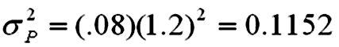

AACSB: Analytic
Blooms: Apply
Difficulty: 2 Medium
Learning Objective: 07-04 Take advantage of an arbitrage opportunity with a portfolio that includes mispriced securities.
Topic: Arbitrage Pricing Theory

33. | Security X has an expected rate of return of 13% and a beta of 1.15. The risk-free rate is 5%, and the market expected rate of return is 15%. According to the capital asset pricing model, security X is _________.  A. fairly priced  B. overpriced  C. underpriced  D. none of these answers  In equilibrium, E(r_{X}) = 5% + 1.15(15% - 5%) = 16.5%.

AACSB: Analytic
Blooms: Apply
Difficulty: 2 Medium
Learning Objective: 07-01 Use the implications of capital market theory to estimate security risk premiums.
Topic: The Capital Asset Pricing Model

34. | The possibility of arbitrage arises when ____________.  A. there is no consensus among investors regarding the future direction of the market, and thus trades are made arbitrarily  B. mispricing among securities creates opportunities for riskless profits  C. two identically risky securities carry the same expected returns  D. investors do not diversify

AACSB: Analytic
Blooms: Remember
Difficulty: 1 Easy
Learning Objective: 07-04 Take advantage of an arbitrage opportunity with a portfolio that includes mispriced securities.
Topic: Arbitrage Pricing Theory

35. | Building a zero-investment portfolio will always involve _____________.  A. an unknown mixture of short and long positions  B. only short positions  C. only long positions  D. equal investments in a short and a long position

AACSB: Analytic
Blooms: Remember
Difficulty: 1 Easy
Learning Objective: 07-04 Take advantage of an arbitrage opportunity with a portfolio that includes mispriced securities.
Topic: Arbitrage Pricing Theory

36. | An important characteristic of market equilibrium is _______________.  A. the presence of many opportunities for creating zero-investment portfolios  B. all investors exhibit the same degree of risk aversion  C. the absence of arbitrage opportunities  D. the lack of liquidity in the market

AACSB: Analytic
Blooms: Remember
Difficulty: 1 Easy
Learning Objective: 07-04 Take advantage of an arbitrage opportunity with a portfolio that includes mispriced securities.
Topic: Arbitrage Pricing Theory

37. | Consider the capital asset pricing model. The market degree of risk aversion, A, is 3. The variance of return on the market portfolio is .0225. If the risk-free rate of return is 4%, the expected return on the market portfolio is _________.  A. 6.75%  B. 9%  C. 10.75%  D. 12%  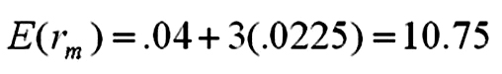

AACSB: Analytic
Blooms: Apply
Difficulty: 2 Medium
Learning Objective: 07-01 Use the implications of capital market theory to estimate security risk premiums.
Topic: The Capital Asset Pricing Model

38. | You invest $600 in security A with a beta of 1.5 and $400 in security B with a beta of .90. The beta of this portfolio is _________.  A. 1.14  B. 1.2  C. 1.26  D. 1.5  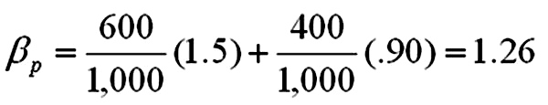

AACSB: Analytic
Blooms: Apply
Difficulty: 2 Medium
Learning Objective: 07-01 Use the implications of capital market theory to estimate security risk premiums.
Topic: The Capital Asset Pricing Model

39. | In a single-factor market model the beta of a stock ________.  A. measures the stock's contribution to the standard deviation of the market portfolio  B. measures the stock's unsystematic risk  C. changes with the variance of the residuals  D. measures the stock's contribution to the standard deviation of the stock

AACSB: Analytic
Blooms: Remember
Difficulty: 2 Medium
Learning Objective: 07-01 Use the implications of capital market theory to estimate security risk premiums.
Topic: The Capital Asset Pricing Model

40. | Security A has an expected rate of return of 12% and a beta of 1.1. The market expected rate of return is 8%, and the risk-free rate is 5%. The alpha of the stock is _________.  A. -1.7%  B. 3.7%  C. 5.5%  D. 8.7%  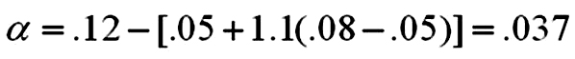

AACSB: Analytic
Blooms: Apply
Difficulty: 2 Medium
Learning Objective: 07-02 Construct and use the security market line.
Topic: The Security Market Line

41. | The variance of the return on the market portfolio is .04 and the expected return on the market portfolio is 20%. If the risk-free rate of return is 10%, the market degree of risk aversion, A, is _________.  A. .5  B. 2.5  C. 3.5  D. 5  A = (.20 - .10)/.04 = 2.5

AACSB: Analytic
Blooms: Apply
Difficulty: 2 Medium
Learning Objective: 07-01 Use the implications of capital market theory to estimate security risk premiums.
Topic: The Capital Asset Pricing Model

42. | The risk-free rate is 4%. The expected market rate of return is 11%. If you expect stock X with a beta of .8 to offer a rate of return of 12%, then you should _________.  A. buy stock X because it is overpriced  B. buy stock X because it is underpriced  C. sell short stock X because it is overpriced  D. sell short stock X because it is underpriced

AACSB: Analytic
Blooms: Apply
Difficulty: 2 Medium
Learning Objective: 07-02 Construct and use the security market line.
Topic: The Security Market Line

43. | Consider the one-factor APT. The standard deviation of return on a well-diversified portfolio is 20%. The standard deviation on the factor portfolio is 12%. The beta of the well-diversified portfolio is approximately _________.  A. .60  B. 1  C. 1.67  D. 3.20  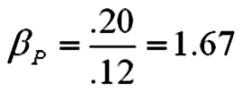

AACSB: Analytic
Blooms: Apply
Difficulty: 2 Medium
Learning Objective: 07-04 Take advantage of an arbitrage opportunity with a portfolio that includes mispriced securities.
Topic: Arbitrage Pricing Theory

44. | The risk-free rate and the expected market rate of return are 6% and 16%, respectively. According to the capital asset pricing model, the expected rate of return on security X with a beta of 1.2 is equal to _________.  A. 12%  B. 17%  C. 18%  D. 23%  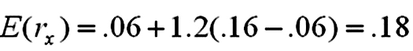

AACSB: Analytic
Blooms: Apply
Difficulty: 2 Medium
Learning Objective: 07-01 Use the implications of capital market theory to estimate security risk premiums.
Topic: The Capital Asset Pricing Model

45. | Consider two stocks, A and B. Stock A has an expected return of 10% and a beta of 1.2. Stock B has an expected return of 14% and a beta of 1.8. The expected market rate of return is 9% and the risk-free rate is 5%. Security __________ would be considered the better buy because _________.  A. A; it offers an expected excess return of .2%  B. A; it offers an expected excess return of 2.2%  C. B; it offers an expected excess return of 1.8%  D. B; it offers an expected return of 2.4%  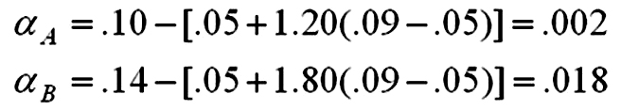

AACSB: Analytic
Blooms: Apply
Difficulty: 3 Hard
Learning Objective: 07-01 Use the implications of capital market theory to estimate security risk premiums.
Topic: The Capital Asset Pricing Model

46. | According to the CAPM, the risk premium an investor expects to receive on any stock or portfolio is _______________.  A. directly related to the risk aversion of the particular investor  B. inversely related to the risk aversion of the particular investor  C. directly related to the beta of the stock  D. inversely related to the alpha of the stock

AACSB: Analytic
Blooms: Remember
Difficulty: 1 Easy
Learning Objective: 07-01 Use the implications of capital market theory to estimate security risk premiums.
Topic: The Capital Asset Pricing Model

47. | In his famous critique of the CAPM, Roll argued that the CAPM ______________.  A. is not testable because the true market portfolio can never be observed  B. is of limited use because systematic risk can never be entirely eliminated  C. should be replaced by the APT  D. should be replaced by the Fama-French three-factor model

AACSB: Analytic
Blooms: Remember
Difficulty: 2 Medium
Learning Objective: 07-01 Use the implications of capital market theory to estimate security risk premiums.
Topic: The CAPM and the Real World

48. | Which of the following variables do Fama and French claim do a better job explaining stock returns than beta?  I. Book-to-market ratio  II. Unexpected change in industrial production  III. Firm size  A. I only  B. I and II only  C. I and III only  D. I, II, and III

AACSB: Analytic
Blooms: Remember
Difficulty: 2 Medium
Learning Objective: 07-03 Specify and use a multifactor security market line.
Topic: Multifactor Models and the CAPM

49. | In a study conducted by Jagannathan and Wang, it was found that the performance of beta in explaining security returns could be considerably enhanced by:  I. Including the unsystematic risk of a stock  II. Including human capital in the market portfolio  III. Allowing for changes in beta over time  A. I and II only  B. II and III only  C. I and III only  D. I, II, and III

AACSB: Analytic
Blooms: Remember
Difficulty: 2 Medium
Learning Objective: 07-01 Use the implications of capital market theory to estimate security risk premiums.
Topic: The CAPM and the Real World

50. | The SML is valid for _______________, and the CML is valid for ______________.  A. only individual assets; well-diversified portfolios only  B. only well-diversified portfolios; only individual assets  C. both well-diversified portfolios and individual assets; both well-diversified portfolios and individual assets  D. both well-diversified portfolios and individual assets; well-diversified portfolios only

AACSB: Analytic
Blooms: Remember
Difficulty: 2 Medium
Learning Objective: 07-02 Construct and use the security market line.
Topic: The Security Market Line

51. | Liquidity is a risk factor that __________.  A. has yet to be accurately measured and incorporated into portfolio management  B. is unaffected by trading mechanisms on various stock exchanges  C. has no effect on the market value of an asset  D. affects bond prices but not stock prices

AACSB: Analytic
Blooms: Remember
Difficulty: 2 Medium
Learning Objective: 07-01 Use the implications of capital market theory to estimate security risk premiums.
Topic: The CAPM and the Real World

52. | Beta is a measure of ______________.  A. total risk  B. relative systematic risk  C. relative nonsystematic risk  D. relative business risk

AACSB: Analytic
Blooms: Remember
Difficulty: 1 Easy
Learning Objective: 07-01 Use the implications of capital market theory to estimate security risk premiums.
Topic: The Capital Asset Pricing Model

53. | According to capital asset pricing theory, the key determinant of portfolio returns is _________.  A. the degree of diversification  B. the systematic risk of the portfolio  C. the firm-specific risk of the portfolio  D. economic factors

AACSB: Analytic
Blooms: Remember
Difficulty: 1 Easy
Learning Objective: 07-01 Use the implications of capital market theory to estimate security risk premiums.
Topic: The Capital Asset Pricing Model

54. | The expected return of the risky-asset portfolio with minimum variance is _________.  A. the market rate of return  B. zero  C. the risk-free rate  D. The answer cannot be determined from the information given.

AACSB: Analytic
Blooms: Remember
Difficulty: 2 Medium
Learning Objective: 07-01 Use the implications of capital market theory to estimate security risk premiums.
Topic: The Capital Asset Pricing Model

55. | According to the CAPM, investors are compensated for all but which of the following?  A. Expected inflation  B. Systematic risk  C. Time value of money  D. Residual risk

AACSB: Analytic
Blooms: Remember
Difficulty: 2 Medium
Learning Objective: 07-01 Use the implications of capital market theory to estimate security risk premiums.
Topic: The Capital Asset Pricing Model

56. | The most significant conceptual difference between the arbitrage pricing theory (APT) and the capital asset pricing model (CAPM) is that the CAPM _____________.  A. places less emphasis on market risk  B. recognizes multiple unsystematic risk factors  C. recognizes only one systematic risk factor  D. recognizes multiple systematic risk factors

AACSB: Analytic
Blooms: Remember
Difficulty: 2 Medium
Learning Objective: 07-04 Take advantage of an arbitrage opportunity with a portfolio that includes mispriced securities.
Topic: Arbitrage Pricing Theory

57. | Arbitrage is __________________________.  A. an example of the law of one price  B. the creation of riskless profits made possible by relative mispricing among securities  C. a common opportunity in modern markets  D. an example of a risky trading strategy based on market forecasting

AACSB: Analytic
Blooms: Remember
Difficulty: 1 Easy
Learning Objective: 07-04 Take advantage of an arbitrage opportunity with a portfolio that includes mispriced securities.
Topic: Arbitrage Pricing Theory

58. | A stock's alpha measures the stock's ____________________.  A. expected return  B. abnormal return  C. excess return  D. residual return

AACSB: Analytic
Blooms: Remember
Difficulty: 2 Medium
Learning Objective: 07-02 Construct and use the security market line.
Topic: The Security Market Line

59. | The measure of unsystematic risk can be found from an index model as _________.  A. residual standard deviation  B. R-square  C. degrees of freedom  D. sum of squares of the regression

AACSB: Analytic
Blooms: Remember
Difficulty: 2 Medium
Learning Objective: 07-01 Use the implications of capital market theory to estimate security risk premiums.
Topic: The CAPM and Index Models

60. | Standard deviation of portfolio returns is a measure of ___________.  A. total risk  B. relative systematic risk  C. relative nonsystematic risk  D. relative business risk

AACSB: Analytic
Blooms: Remember
Difficulty: 1 Easy
Learning Objective: 07-01 Use the implications of capital market theory to estimate security risk premiums.
Topic: The Capital Asset Pricing Model

61. | One of the main problems with the arbitrage pricing theory is __________.  A. its use of several factors instead of a single market index to explain the risk-return relationship  B. the introduction of nonsystematic risk as a key factor in the risk-return relationship  C. that the APT requires an even larger number of unrealistic assumptions than does the CAPM  D. the model fails to identify the key macroeconomic variables in the risk-return relationship

AACSB: Analytic
Blooms: Remember
Difficulty: 2 Medium
Learning Objective: 07-04 Take advantage of an arbitrage opportunity with a portfolio that includes mispriced securities.
Topic: Arbitrage Pricing Theory

62. | You run a regression of a stock's returns versus a market index and find the following:  Based on the data, you know that the stock _____.  A. earned a positive alpha that is statistically significantly different from zero  B. has a beta precisely equal to .890  C. has a beta that is likely to be anything between .6541 and 1.465 inclusive  D. has no systematic risk

AACSB: Analytic
Blooms: Apply
Difficulty: 3 Hard
Learning Objective: 07-01 Use the implications of capital market theory to estimate security risk premiums.
Topic: The Capital Asset Pricing Model

63. | The expected return on the market portfolio is 15%. The risk-free rate is 8%. The expected return on SDA Corp. common stock is 16%. The beta of SDA Corp. common stock is 1.25. Within the context of the capital asset pricing model, _________.  A. SDA Corp. stock is underpriced  B. SDA Corp. stock is fairly priced  C. SDA Corp. stock's alpha is -.75%  D. SDA Corp. stock alpha is .75%

AACSB: Analytic
Blooms: Apply
Difficulty: 2 Medium
Learning Objective: 07-02 Construct and use the security market line.
Topic: The Security Market Line (B-level head)

64. | Assume that both X and Y are well-diversified portfolios and the risk-free rate is 8%. Portfolio X has an expected return of 14% and a beta of 1. Portfolio Y has an expected return of 9.5% and a beta of .25. In this situation, you would conclude that portfolios X and Y _________.  A. are in equilibrium  B. offer an arbitrage opportunity  C. are both underpriced  D. are both fairly priced  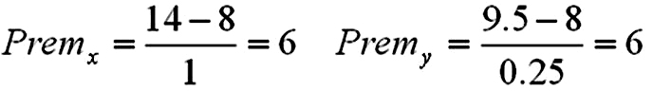  Thus, there are no arbitrage opportunities, and X and Y are in equilibrium.

AACSB: Analytic
Blooms: Apply
Difficulty: 2 Medium
Learning Objective: 07-01 Use the implications of capital market theory to estimate security risk premiums.
Topic: The Capital Asset Pricing Model

65. | What is the expected return on the market?  A. 0%  B. 5%  C. 10%  D. 15%

AACSB: Analytic
Blooms: Apply
Difficulty: 1 Easy
Learning Objective: 07-02 Construct and use the security market line.
Topic: The Security Market Line

66. | What is the beta for a portfolio with an expected return of 12.5%?  A. 0  B. 1  C. 1.5  D. 2  Since r_{f} = 5% and E(r_{M}) = 10%, from the CAPM we know that 12.5% = 5% + beta(10% - 5%), and therefore beta = 1.5.

AACSB: Analytic
Blooms: Apply
Difficulty: 2 Medium
Learning Objective: 07-01 Use the implications of capital market theory to estimate security risk premiums.
Topic: The Capital Asset Pricing Model

67. | What is the expected return for a portfolio with a beta of .5?  A. 5%  B. 7.5%  C. 12.5%  D. 15%  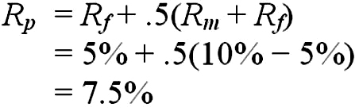

AACSB: Analytic
Blooms: Apply
Difficulty: 2 Medium
Learning Objective: 07-01 Use the implications of capital market theory to estimate security risk premiums.
Topic: The Capital Asset Pricing Model

68. | What is the alpha of a portfolio with a beta of 2 and actual return of 15%?  A. 0%  B. 13%  C. 15%  D. 17%  CAPM E(r_{i}) = 5% + 2(10% - 5%) = 15%; Alpha = Actual return - Expected return = 15% - 15% = 0%  A portfolio with a return of 15% and a beta of 2 lies on the SML and therefore has an alpha of zero.

AACSB: Analytic
Blooms: Apply
Difficulty: 2 Medium
Learning Objective: 07-02 Construct and use the security market line.
Topic: The Security Market Line (B-level head)

69. | If the simple CAPM is valid and all portfolios are priced correctly, which of the situations below is possible? Consider each situation independently, and assume the risk-free rate is 5%.  A. Option A  B. Option B  C. Option C  D. Option D  A) Not possible—two portfolios with different betas cannot have the same expected return.  B) Not possible—under CAPM market portfolio must yield highest CAL.  C) Not possible—portfolio A and the market have different excess returns per unit of risk.  D) Possible 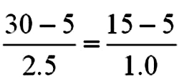

AACSB: Analytic
Blooms: Apply
Difficulty: 3 Hard
Learning Objective: 07-01 Use the implications of capital market theory to estimate security risk premiums.
Topic: The Capital Asset Pricing Model

70. | Two investment advisers are comparing performance. Adviser A averaged a 20% return with a portfolio beta of 1.5, and adviser B averaged a 15% return with a portfolio beta of 1.2. If the T-bill rate was 5% and the market return during the period was 13%, which adviser was the better stock picker?  A. Advisor A was better because he generated a larger alpha.  B. Advisor B was better because she generated a larger alpha.  C. Advisor A was better because he generated a higher return.  D. Advisor B was better because she achieved a good return with a lower beta.  Required return A = 5% + (13% - 5%)(1.5) = 17%  Required return B = 5% + (13% - 5%)(1.2) = 14.6%  α_{A} = Actual return A - Required return A = 20% - 17% = 3%  α_{B} = Actual return B - Required return B = 15% - 14.6% = .4%

AACSB: Analytic
Blooms: Apply
Difficulty: 3 Hard
Learning Objective: 07-02 Construct and use the security market line.
Topic: The Security Market Line (B-level head)

71. | The expected return on the market is the risk-free rate plus the _____________.  A. diversified returns  B. equilibrium risk premium  C. historical market return  D. unsystematic return

AACSB: Analytic
Blooms: Remember
Difficulty: 1 Easy
Learning Objective: 07-01 Use the implications of capital market theory to estimate security risk premiums.
Topic: The Capital Asset Pricing Model

72. | You consider buying a share of stock at a price of $25. The stock is expected to pay a dividend of $1.50 next year, and your advisory service tells you that you can expect to sell the stock in 1 year for $28. The stock's beta is 1.1, r_{f} is 6%, and E[r_{m}] = 16%. What is the stock's abnormal return?  A. 1%  B. 2%  C. -1%  D. -2%  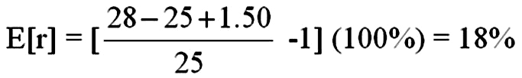  Required return = 6% + (16% - 6%)(1.1) = 17%  Abnormal return = 18% - 17% = 1%

AACSB: Analytic
Blooms: Apply
Difficulty: 3 Hard
Learning Objective: 07-02 Construct and use the security market line.
Topic: The Security Market Line (B-level head)

73. | If the beta of the market index is 1 and the standard deviation of the market index increases from 12% to 18%, what is the new beta of the market index?  A. .8  B. 1  C. 1.2  D. 1.5  Market beta always equals 1 regardless of market volatility.

AACSB: Analytic
Blooms: Apply
Difficulty: 1 Easy
Learning Objective: 07-01 Use the implications of capital market theory to estimate security risk premiums.
Topic: The Capital Asset Pricing Model

74. | According to the CAPM, what is the market risk premium given an expected return on a security of 13.6%, a stock beta of 1.2, and a risk-free interest rate of 4%?  A. 4%  B. 4.8%  C. 6.6%  D. 8%  13.6 = 4 + 1.2 × (MRP); MRP = 8%

AACSB: Analytic
Blooms: Apply
Difficulty: 2 Medium
Learning Objective: 07-01 Use the implications of capital market theory to estimate security risk premiums.
Topic: The Capital Asset Pricing Model

75. | According to the CAPM, what is the expected market return given an expected return on a security of 15.8%, a stock beta of 1.2, and a risk-free interest rate of 5%?  A. 5%  B. 9%  C. 13%  D. 14%  15.8 = 5 + 1.2 × (MRP); MRP = 9%; Expected market return = 5 + 9 = 14%

AACSB: Analytic
Blooms: Apply
Difficulty: 2 Medium
Learning Objective: 07-01 Use the implications of capital market theory to estimate security risk premiums.
Topic: The Capital Asset Pricing Model

76. | What is the expected return on a stock with a beta of .8, given a risk-free rate of 3.5% and an expected market return of 15.5%?  A. 3.8%  B. 13.1%  C. 15.6%  D. 19.1%  Expected return = 3.5 + (.8)(15.5 - 3.5) = 13.1%

AACSB: Analytic
Blooms: Apply
Difficulty: 2 Medium
Learning Objective: 07-01 Use the implications of capital market theory to estimate security risk premiums.
Topic: The Capital Asset Pricing Model

77. | Research has identified two systematic factors that affect U.S. stock returns. The factors are growth in industrial production and changes in long-term interest rates. Industrial production growth is expected to be 3%, and long-term interest rates are expected to increase by 1%. You are analyzing a stock that has a beta of 1.2 on the industrial production factor and .5 on the interest rate factor. It currently has an expected return of 12%. However, if industrial production actually grows 5% and interest rates drop 2%, what is your best guess of the stock's return?  A. 15.9%  B. 12.9%  C. 13.2%  D. 12%  E[r_{new}] = 12% + (5% - 3%)(1.2) + (-2% - 1%)(.5) = 12.9%

AACSB: Analytic
Blooms: Apply
Difficulty: 3 Hard
Learning Objective: 07-05 Use arbitrage pricing theory with more than one factor to identify mispriced securities.
Topic: Multifactor Generalization of the APT and CAPM (B-level head)

78. | A stock has a beta of 1.3. The systematic risk of this stock is ____________ the stock market as a whole.  A. higher than  B. lower than  C. equal to  D. indeterminable compared to

AACSB: Analytic
Blooms: Remember
Difficulty: 2 Medium
Learning Objective: 07-01 Use the implications of capital market theory to estimate security risk premiums.
Topic: The Capital Asset Pricing Model

79. | There are two independent economic factors, M1 and M2. The risk-free rate is 5%, and all stocks have independent firm-specific components with a standard deviation of 25%. Portfolios A and B are well diversified. Given the data below, which equation provides the correct pricing model?  A. E(r_{P}) = 5 + 1.12β_{P1} + 11.86β_{P2}  B. E(r_{P}) = 5 + 4.96β_{P1} + 13.26β_{P2}  C. E(r_{P}) = 5 + 3.23β_{P1} + 8.46β_{P2}  D. E(r_{P}) = 5 + 8.71β_{P1} + 9.68β_{P2}  35 = 5 + 1.5 γ₁ + 1.75 γ₂; solve for γ₁  γ₁ = 20 - 1.1667γ₂  20 = 5 + γ₁ + .65γ₂; sub in γ₁  20 = 5 + 20 - 1.1667 γ₂ + .65 γ₂  γ₂ = 9.68% γ₁ = 8.71%

AACSB: Analytic
Blooms: Apply
Difficulty: 3 Hard
Learning Objective: 07-03 Specify and use a multifactor security market line.
Topic: Multifactor Models and the CAPM

80. | Using the index model, the alpha of a stock is 3%, the beta is 1.1, and the market return is 10%. What is the residual given an actual return of 15%?  A. .0%  B. 1%  C. 2%  D. 3%  Residual = 15 - (3 + 1.1 × 10) = 1%

AACSB: Analytic
Blooms: Apply
Difficulty: 2 Medium
Learning Objective: 07-01 Use the implications of capital market theory to estimate security risk premiums.
Topic: The CAPM and Index Models

81. | The risk premium for exposure to aluminum commodity prices is 4%, and the firm has a beta relative to aluminum commodity prices of .6. The risk premium for exposure to GDP changes is 6%, and the firm has a beta relative to GDP of 1.2. If the risk-free rate is 4%, what is the expected return on this stock?  A. 10%  B. 11.5%  C. 13.6%  D. 14%  Return = .04 + .6(.04) + 1.2(.06) = .136

AACSB: Analytic
Blooms: Apply
Difficulty: 2 Medium
Learning Objective: 07-05 Use arbitrage pricing theory with more than one factor to identify mispriced securities.
Topic: Multifactor Generalization of the APT and CAPM

82. | The two-factor model on a stock provides a risk premium for exposure to market risk of 9%, a risk premium for exposure to interest rate risk of (-1.3%), and a risk-free rate of 3.5%. The beta for exposure to market risk is 1, and the beta for exposure to interest rate risk is also 1. What is the expected return on the stock?  A. 8.7%  B. 11.2%  C. 13.8%  D. 15.2%  Return = 3.5 + 9 - 1.3 = 11.2%

AACSB: Analytic
Blooms: Apply
Difficulty: 2 Medium
Learning Objective: 07-03 Specify and use a multifactor security market line.
Topic: Multifactor Models and the CAPM

83. | The risk premium for exposure to exchange rates is 5%, and the firm has a beta relative to exchange rates of .4. The risk premium for exposure to the consumer price index is -6%, and the firm has a beta relative to the CPI of .8. If the risk-free rate is 3%, what is the expected return on this stock?  A. .2%  B. 1.5%  C. 3.6%  D. 4%  Return = .03 + .4(.05) + .8(-.06) = .002

AACSB: Analytic
Blooms: Apply
Difficulty: 2 Medium
Learning Objective: 07-03 Specify and use a multifactor security market line.
Topic: Multifactor Models and the CAPM

84. | The two-factor model on a stock provides a risk premium for exposure to market risk of 12%, a risk premium for exposure to silver commodity prices of 3.5%, and a risk-free rate of 4%. The beta for exposure to market risk is 1, and the beta for exposure to commodity prices is also 1. What is the expected return on the stock?  A. 11.6%  B. 13%  C. 15.3%  D. 19.5%  Return = 3.5 + 4 + 12 = 19.5%

AACSB: Analytic
Blooms: Apply
Difficulty: 2 Medium
Learning Objective: 07-03 Specify and use a multifactor security market line.
Topic: Multifactor Models and the CAPM

85. | The measure of risk used in the capital asset pricing model is ___________.  A. specific risk  B. the standard deviation of returns  C. reinvestment risk  D. beta

AACSB: Analytic
Blooms: Remember
Difficulty: 1 Easy
Learning Objective: 07-01 Use the implications of capital market theory to estimate security risk premiums.
Topic: The Capital Asset Pricing Model

